**Streamling workflows with pipelines:**

1. Loading dataset
2. Combining transformers and estimators in a pipeline

Instead of going through the fitting and transformation steps for the training and test dataset separately, we can chian the StandardScaler,PCA,and LogisticRegression objects in a pipeline:

**Using K-fold cross-validation to assess model performance**

These methods can help us to obtain reliable estimates of the model’s generalization error, that is, how well the model performs on unseen data.

1. **Holdout cross-validation method**

A better way of using the holdout method for model selection is to separate the data into three parts: a training set, a validation set, and a test set. The training set is used to fit the different models, and the performance on the validation set is the used for the model selection. Illustrations as follow:

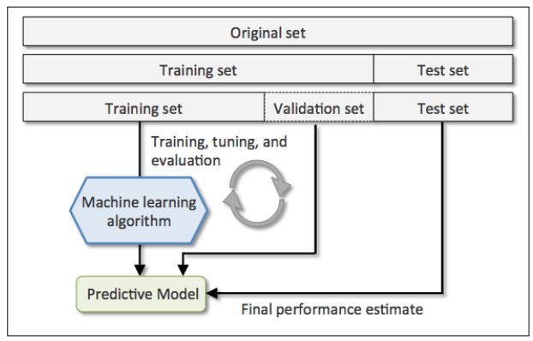

The disadvantage of the holdout method is that the performance estimate is sensitive to how we partition the training set into the training and validation subsets.

1. **K-fold cross-validation**

IN k-fold cross-validation, we randomly split the training dataset into k folds without replacement, where k-1 folds are used for the model training and one fold is used for testing.

Typically, we use k-fold cross-validation for model tuning, that is, fnding the optimal hyperparameter values that yield a satisfying generalization performance. Once we have found satisfactory hyperparameter values, we can retrain the model on the complete training set and obtain a fnal performance estimate using the independent test set.

If we are working with relatively small training sets , it can be useful to increase the number of folds. If we increase the value of k, more training data will be used in each iteration, which results in a lower bias towards estimating the generalization performance by averaging the individual model estimates. However , large values of k will also increase the runtime of the cross-validation algorithm and yield estimates with higher variance since the training folds will be more similar to each other. On the other hand, if we are working with large datasets, we can choose a smaller value for k, for example, k = 5 , and still obtain an accurate estimate of the average performance of the model while reducing the computational cost of refitting and evaluating the model on the different folds.

**Debugging algorithms with learning and validation curves**

By plotting the model training and validation accuracies as functions of the training set size, we can easily detect whether the model suffers from high variance or high bias, and whether the collection of more data could help to address this problem

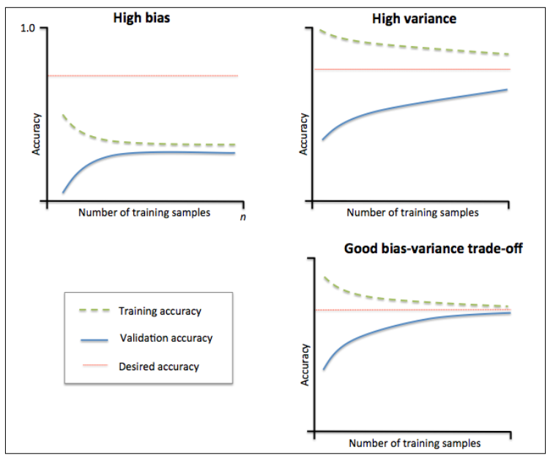

The training accuracy curve is wrong in the figure above.

Upper-left: high-bias (underfit), has both low training and cross-validation accuracy

Solutions: 1. Increase the number of parameters of the model , collecting or constructing additional feature;2. Decreasing the degree of regularization, (SVM or logistic regression)

Upper-right: high-variance, a large gap between the training and cross-validation accuracy

Solutions: 1. Collect more training data or reduce the complexity of the model, eg. Increasing the regularization parameter;2. Decrease the number of features via feature selection or feature extraction.

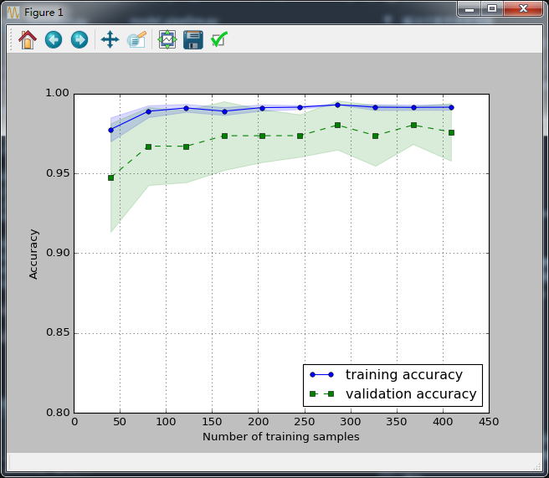

**Addressing overfitting and underfitting with validation curves:**

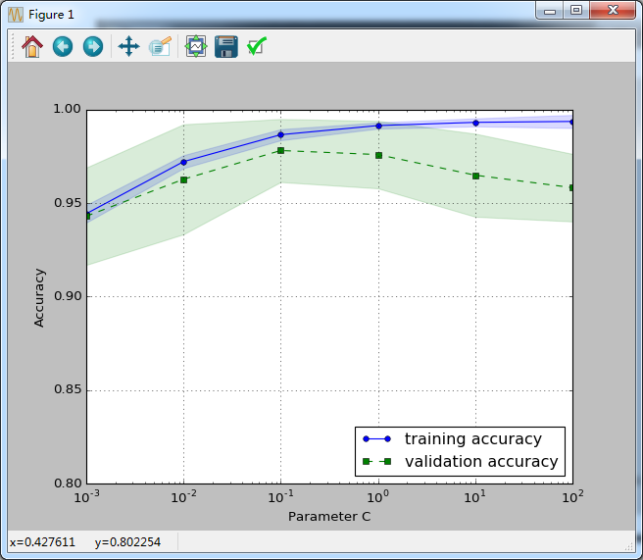

Although the differences in the accuracy for varying values of C are subtle, we can see that the model slightly underfits the data when we increase the regularization strength (small values of C). However ,for large values, it means lowering the strength of regularization ,so the model tends to slightly overfit the data. In this case, the sweet spot appears to be around C= 0.1

**Fine-tuning machine learning models via grid search**

Two types of parameters: 1. Those learned from the training data, eg. Weights in logistic regression, 2. Parameters of a learning algorithm (tuning parameters, also called hyperparamters, regularation parameter in logistic regression or depth parameter of a decision tree)

It’s a bruth-force exhaustive search paradigm where we specify a list of values for different hyperparamters, and the computer evaluates the model performance for each combination of those to obtain the optimal set:

**Algorithm selection with nested cross-validation**

If we want to select among different machine learning algorithms though, another recommended approach is **nested cross-validation**.

In nested cross-validation , we have an outer k-fold cross-validation loop to split the data into training and test folds, and an inner loop is used to select the model using k-fold cross-validation on the training fold. After model selection , the test fold is then used to evaluate the model performance. Following figure explains the concept

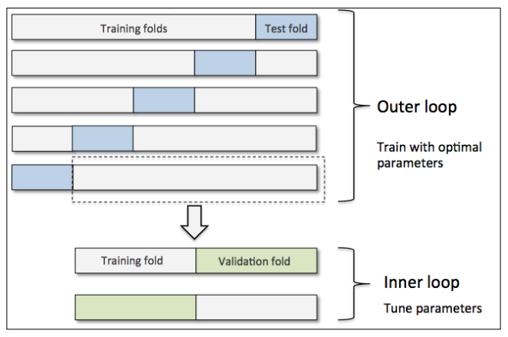

**Looking at different performance evaluation metrics**

Confusion matrix: a matrix that lays out the performance of a learning algorithm. The confusion matrix is simply a square matrix that reports the counts of the true positive, true negative, false positive, and false negative predictions of a classifier

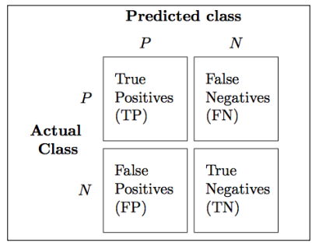

Different:

Error (ERR) = 

ACC(accuracy) = 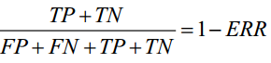

TPR (true positive rate) = 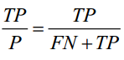

FPR (false positive rate) = 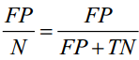

PRE (Precison,查准率) = 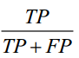

REC (recall,查全率) = 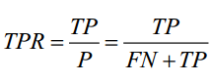

查准率和查全率 是一对矛盾的度量.一般来说,查准率高时,查全率往往偏低;而查全率高时,查准率往往偏低.

In Practice, combination of precision and recall is used, the so-called F1-score:

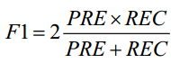

在商品推荐系统中，为了尽可能少打扰用户，更希望推荐内容是用户感兴趣的，此时查准率更重要；而在逃犯信息检索系统中，更希望尽可能少漏掉逃犯，此时查全率更重要。F1度量的一般形式—Fbeta, 能让我们表达出对查准率/查全率的不同偏好，它定义为：



其中，



**Plotting a receiver operating characteristic**

**The scoring metrics for multiclass classifcation**

The micro-average of the precision score in a k-class system can be calculated as follows:

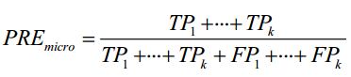

The macro-average is simply calculated as the average scores of the different systems:

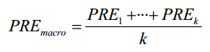

**ROC 与 AUC**

在不同的应用任务中，我们可根据任务需求来采用不同的截断点，例如若我们更重视“查准率”，则可选择排序中靠前的位置进行截断；若更重视“查全率”，则可选择靠后的位置进行截断。因此，排序本身的质量好坏，体现了综合考虑学习期在不同任务下的“期望泛化性能”的好坏，或者说，“一般情况下”泛化性能的好坏。

ROC 全程 “受试者工作特征”（Receiver Operating Characteristic）曲线：

我们根据学习器的预测结果对样例进行排序，按此顺序逐个把样本作为正例进行预测，每次计算出两个重要量的值，分别以它们为横、纵坐标作图，就得到了“ROC曲线”。ROC曲线的纵轴是“真正例率”（True Positive Rate,简称TPR）,横轴是“假正例率”（False Positive Rate,简称FPR）.

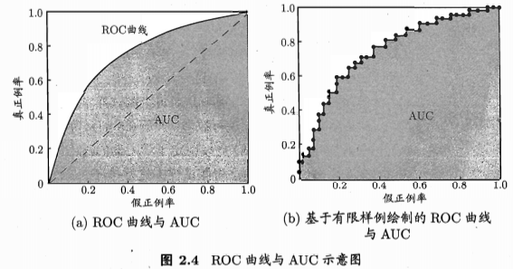

若一个学习器的ROC曲线被另一个学习器的曲线完全“包住”，则可断言后者的性能优于前者；若两个学习器的ROC曲线发生交叉，则难以一般性断言两者熟优熟劣。此时如果一定要进行比较，则较为合理的判断时比较ROC曲线下的面积，即AUC（Area Under ROC Curve）.

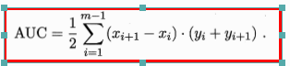

**比较检验**

统计假设检验（hypothesis test）为我们进行学习器性能比较提供了重要依据。

* + 1. 假设检验

Reference:

1. Python machine learning
2. <https://en.wikipedia.org/wiki/Receiver_operating_characteristic>
3. *The Use of the Area Under the ROC Curve in the Evaluation of Machine Learning Algorithms*
4. *机器学习_周志华*